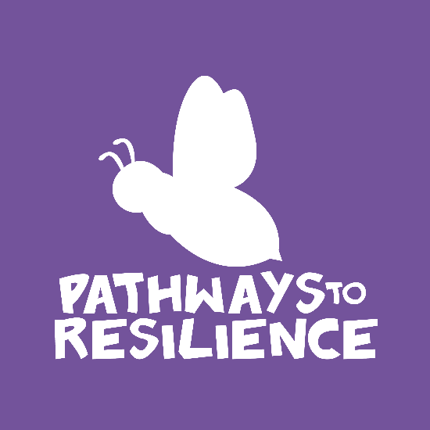
building resilient families tour 2016
CAIRNS
Cairns Wellbeing Centre
Pat Gosper Place
Cnr Lake & Grove Streets, Cairns

Monday 25th to Friday 29th of JULY

All seminars are 100% subsidised by the Tim Fairfax Family Foundation
Expression of Interest Form
Please complete the form below and return via email to community@pathwaystoresilience.org no later than the 18th of July to secure your place at these fully-subsidised workshops.
Name
Organisation/Address
Email Address
Phone Number
Please Indicate the session you would like to attend by placing a tick in the left hand column.
Monday, 25th July - 6.00pm to 8.30pm (training will be at Cairns City Library)
Tuesday, 26th July – 8.00am to 1.00pm
Thursday, 28th July – 8.00am to 1.00pm
Wings – Social and Emotional Wellbeing in Early Years
Monday, 25th July
4.00pm to 5.30pm
Looking Beyond Behaviour
Tuesday, 26th July
4.00pm to 5.30pm
Principles of Resilience
P.T.O
Tuesday, 26th July
6.00pm to 7.30pm
An Introduction to Mindfulness
Wednesday, 27th July
4.30pm to 6.00pm
An Introduction to Neuroscience
Wednesday, 27th July
6.30pm to 8.00pm
How to Deliver the “Brain Talk for Kids”
Thursday, 28th July
4.00pm to 5.30pm
An Introduction to Growth Mindset
Online Training - Fun FRIENDS Facilitator Training (4 to 7 years olds)
FRIENDS Foundations – Wednesday, 17th August – 3.30pm to 5.00pm
Fun FRIENDS Part I – Monday, 22nd August – 3.30pm to 5.30pm
Fun FRIENDS Part II – Monday, 5th September – 3.30pm to 5.30pm
Online Training - FRIENDS For Life Facilitator Training (7 to 11 year olds)
FRIENDS Foundations – Wednesday, 17th August – 3.30pm to 5.00pm
FRIENDS for Life Part I – Tuesday, 23rd August – 3.30pm to 5.30pm
FRIENDS for Life Part II – Tuesday, 6th September – 3.30pm to 5.30pm
PLEASE EMAIL THIS COMPLETED FORM TO COMMUNITY@PATHWAYSTORESILIENCE.ORG
School Visits:
Brain Talk for Kids and Using the Brain for Happiness are available throughout this week and are free of charge to all schools.

Please see booking form to secure your place. These fill very fast so please do not hesitate.

All these seminars and talks are completely free of charge thanks to the Tim Fairfax Family Foundation

